Phase 5: Submission

Tittle: Smart Public Restroom

Name: johncy mery.a

Naan Mudhalvan id: au953021106026

College code: 9530

Smart Public Restroom Using IoT

Slide 1: Title

Title: "Smart Public Restroom Using IoT"

Subtitle: "Innovation for Better Public Hygiene"

Your Name :Johncy mery.A

Slide 2: Introduction

* Briefly introduce the topic and its importance.
* State the objectives of the presentation.

Slide 3: Project Overview

* Provide an overview of the Smart Public Restroom project.
* Mention its goals and key features.

Slide 4: Project Objectives

* Describe the objectives of the project, focusing on improving public restroom facilities through IoT technology.

Slide 5: IoT Device Setup

* Explain the setup of IoT devices in the restroom.
* Discuss the hardware components, sensors, and their placement.

Slide 6: Data-Sharing Platform

* Describe the data-sharing platform and its role in collecting and analyzing data from IoT devices.

Slide 7: Technical Implementation

* Discuss the technical aspects of the project.
* Explain how IoT devices are connected and how data is transmitted to the platform.

Slide 8: IoT Device Diagram

* Include a diagram or schematic of the IoT device setup in the restroom.
* Label key components and their functions.

Slide 9: Data-Sharing Platform Diagram

* Include a diagram illustrating the architecture of the data-sharing platform.
* Highlight data flow and processing.

Slide 10: Code Implementation

* Explain the code and software used to integrate IoT devices with the data-sharing platform.
* Provide an overview of the Python code used for this purpose.

Slide 11: User Interface

* Showcase screenshots and images of the user interface.
* Highlight user interaction and how data is presented.

Slide 12: Project Details

* Provide a detailed explanation of the project, including design thinking, development phases, and objectives.

Slide 13: Instructions for Replication

* Share instructions on how to replicate the project.
* Explain how to set up IoT devices, develop the data-sharing platform, and integrate them using Python.

Slide 14: GitHub Repository

* Provide a link to the GitHub repository containing the project's code and files.

Abstract:

* The key objectives of this initiative are to improve hygiene standards by implementing real-time monitoring and maintenance systems, optimize resource usage through the integration of Internet of Things (IoT) sensors, enhance accessibility for individuals with disabilities, and bolster security to deter vandalism and ensure user safety. Additionally, the project aims to elevate the overall user experience by providing real-time information about restroom availability and incorporating modern amenities such as baby-changing stations, hygiene products, and comfortable seating.

Introduction:

* Smart restrooms in airports are technologically advanced restroom facilities that use various sensors, automation, and data analysis to improve hygiene, maintenance, and user experience.
* Many smart toilets have automatic flushing and hands-free operation (especially after COVID) to help keep surfaces and floors clean.
* Most of the public toilets are not clean due to the irresponsible peoples who often forget to flush the toilet after using it.
* In India all the state and central government are allotting numerous funds for constructing public toilets.
* The central government under “SWACH BHARAT MISSION” has built a vast amount of new toilets to provide the citizens a healthy and hygienic environment.
* Therefore cleaning of public toilets is equally important as cleaning of household toilets.
* So we have developed a mechanism to flush the toilets automatically by utilizing the human weight.
* The mechanism does not require any external power or human concern.Rather, it just works mechanically utilizing the weight of the person sitting on it.
* Our smart toilet is the only system in the markets offering concealed arms over the bowl to clean and dry the bowl and surrounding walls up to 80cm.

Materials Required:

* Aurdino
* Aurdino IDE Software
* Ultrasonic sensor
* DC Motor
* LCD
* Potentiometer
* Breadboard
* Led
* Resistor
* Connecting Wires

Software used: Aurdino IDE

* Arduino Integrated Development Environment (IDE) is an open source IDE that allows users to write code and upload it to any Arduino board.
* Arduino IDE is written in Java and is compatible with Windows, macOS and Linux operating systems.
* Arduino is important part in robotics because it provide creativity and problem-solving.
* It is plugged in the computer and programmed with easy commands i.e. when Arduino is placed in a circuit, and it will manipulate the functioning of the device.
* It emphasizes the involvement of Arduino in many things around.

Hardware used: TINKERCAD

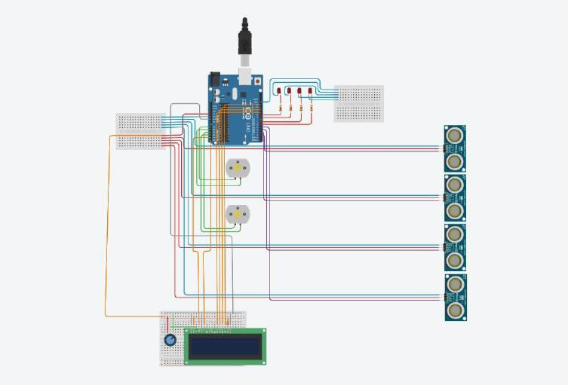

Explanation about the compounents used:

Arduino:

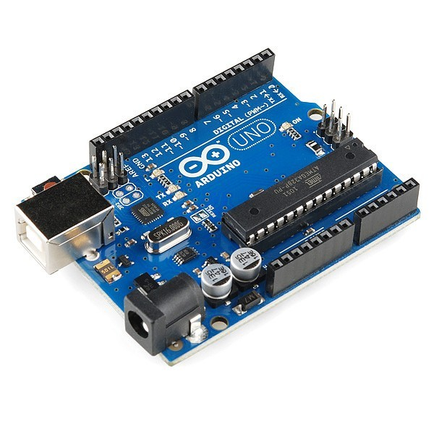

* Arduino is an open-source electronics platform that is popular for its simplicity and versatility. It consists of both hardware and software components and is designed for hobbyists, students, and professionals to create a wide range of interactive and embedded projects.

Aurdino IDE Software:

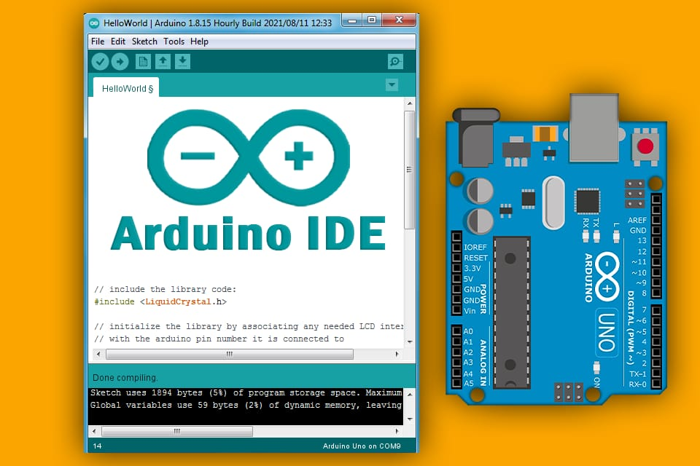

* Arduino Integrated Development Environment (IDE) is an open source IDE that allows users to write code and upload it to any Arduino board.
* Arduino IDE is written in Java and is compatible with Windows, macOS and Linux operating systems.
* Arduino is important part in robotics because it provide creativity and problem-solving.
* It is plugged in the computer and programmed with easy commands i.e. when Arduino is placed in a circuit, and it will manipulate the functioning of the device.
* It emphasizes the involvement of Arduino in many things around.

Ultrasonic sensor:

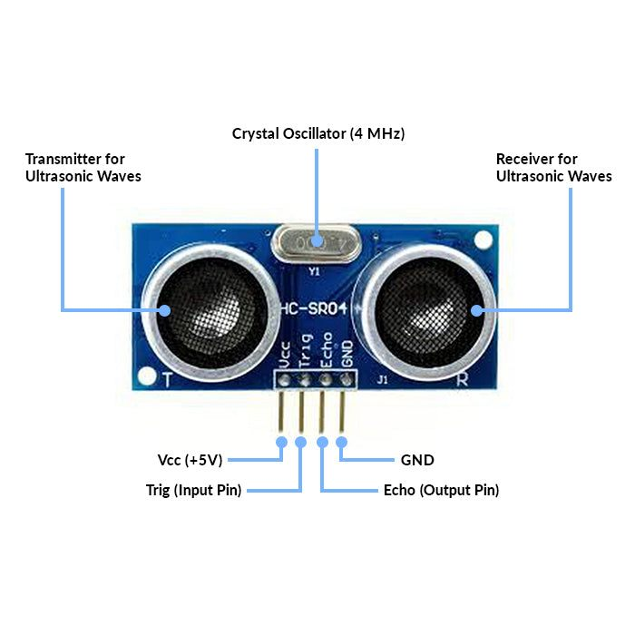

* An ultrasonic sensor is a device that measures the distance to an object or obstacle by emitting high-frequency sound waves (ultrasonic waves) and then calculating the time it takes for the sound waves to bounce back after hitting the object. These sensors are also known as ultrasonic distance sensors or ultrasonic rangefinders.

DC Motor:

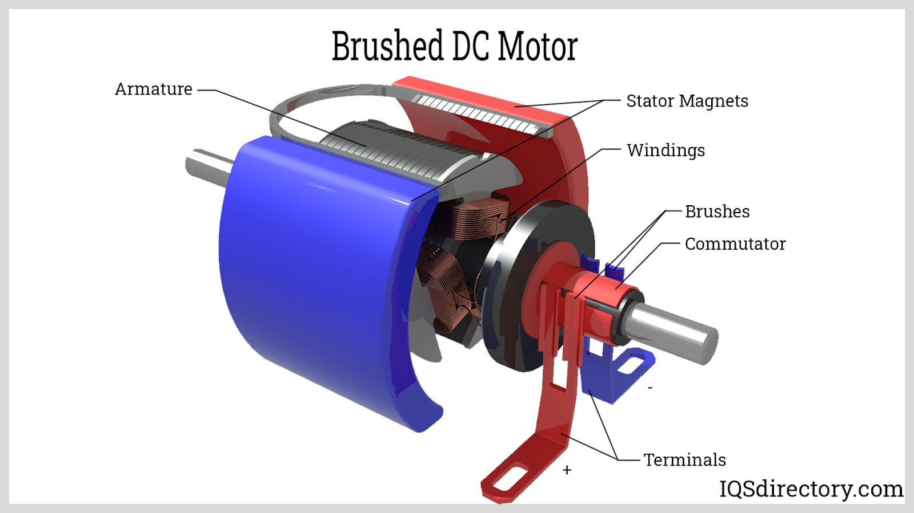

* A DC motor, short for Direct Current motor, is an electrical machine that converts electrical energy into mechanical rotational motion.
* DC motors operate on the principle of Lorentz force, where a current-carrying conductor (in this case, the coil windings of the motor) experiences a force when placed in a magnetic field.
* They are an essential component in many electromechanical systems and are often used in conjunction with microcontrollers or motor driver circuits to achieve precise control and automation.

LCD (Liquid Crystal Display):

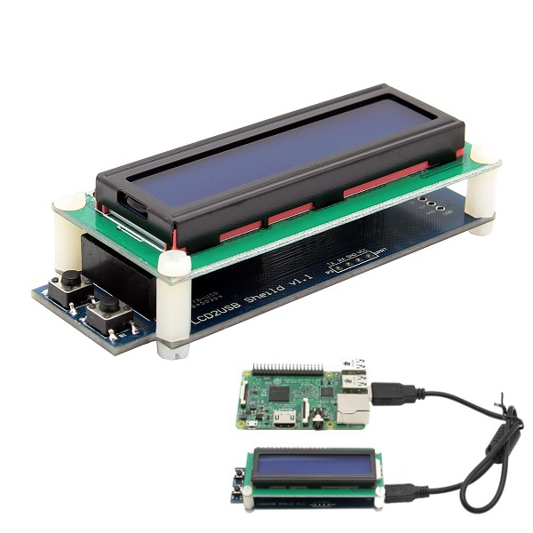

* LCD stands for "Liquid Crystal Display," and it is a type of flat-panel display technology used in a wide range of electronic devices, including televisions, computer monitors, smartphones, and more.
* LCDs are known for their thin, lightweight, and energy-efficient design, which makes them well-suited for various applications.
* LCD technology has been widely adopted for various purposes due to its clarity, energy efficiency, and the ability to create high-resolution displays.
* It is used in a variety of devices, including computer monitors, televisions, digital cameras, smartphones, calculators, and many other consumer and industrial electronics.

Potentiometer:

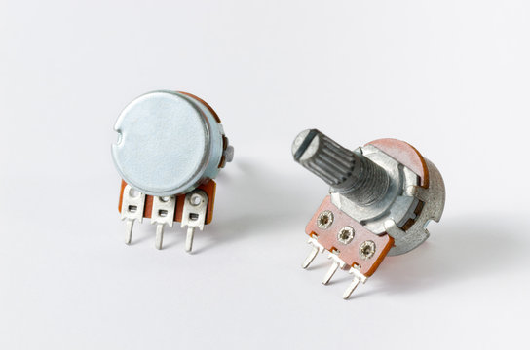

* A potentiometer, often referred to as a "pot," is a simple yet versatile electrical component used for measuring and controlling electrical resistance.
* It consists of a resistive element and a sliding contact, which can be adjusted to change the resistance value. Potentiometers have various applications, from adjusting audio volume in electronic devices to controlling the position of servos in robotics.

Breadboard:

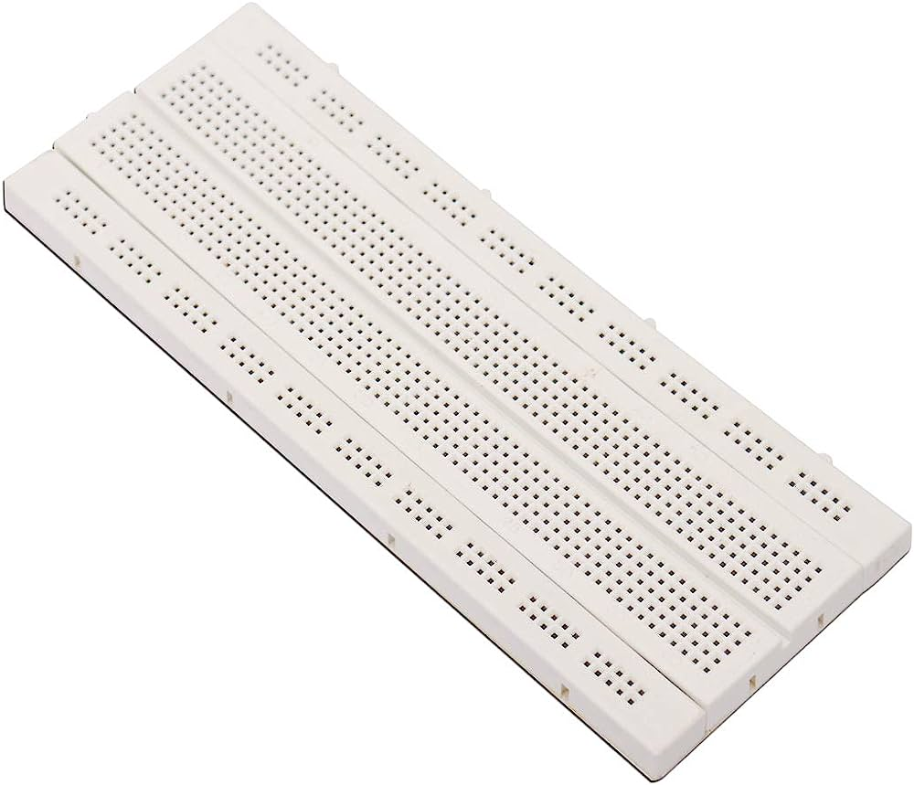

* A breadboard, also known as a prototyping board or solderless breadboard, is an essential tool in electronics for designing, testing, and prototyping electrical circuits without the need for soldering.
* It allows you to build and experiment with circuits quickly and easily.

Led(Light-Emitting Diode)

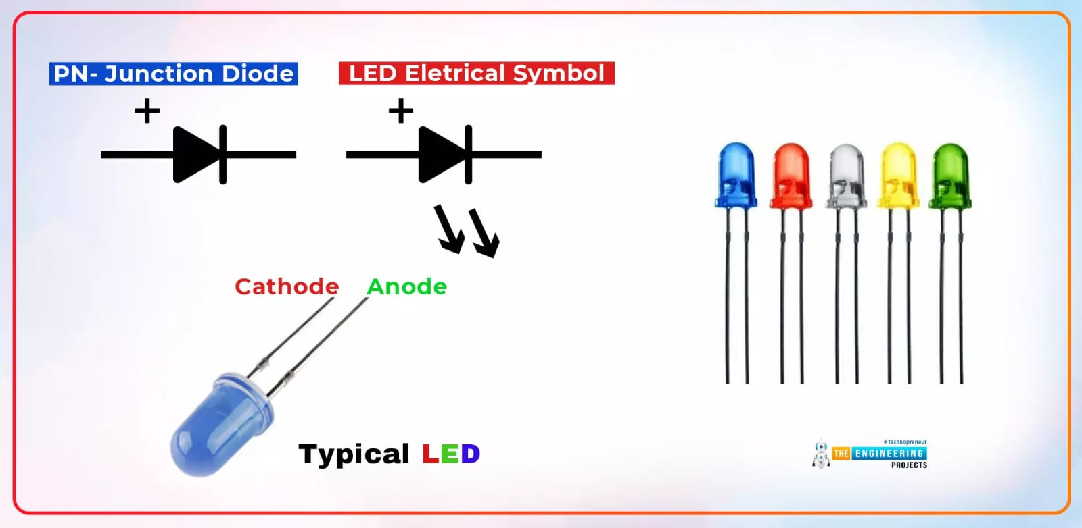

* LED stands for "Light-Emitting Diode." It is a semiconductor device that emits light when an electric current passes through it. LEDs are widely used in various applications, including indicator lights, display screens, lighting, and more.
* An LED, or Light-Emitting Diode, is a tiny device made of special materials.
* When you send electricity through it, it makes the electrons in those materials excited.
* This excitement causes them to give off light, like tiny particles of light called photons.
* LEDs have a unique structure called a p-n junction, where two different semiconductor materials meet.
* When you connect an electric current to this junction, it makes the electrons from one material flow into the other, and when they meet, they release light.

Resistor:

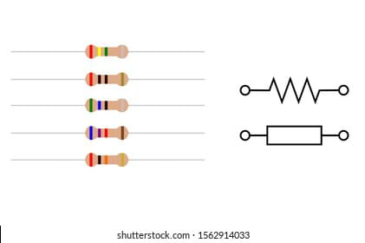

* A resistor is a passive two-terminal electrical component that is designed to restrict the flow of electric current.
* It is one of the most fundamental and commonly used components in electronics and electrical circuits.
* Resistors are used to control the amount of current in a circuit, to divide voltage, to limit current to protect other components, and to perform various other functions.

Circuit Diagram :

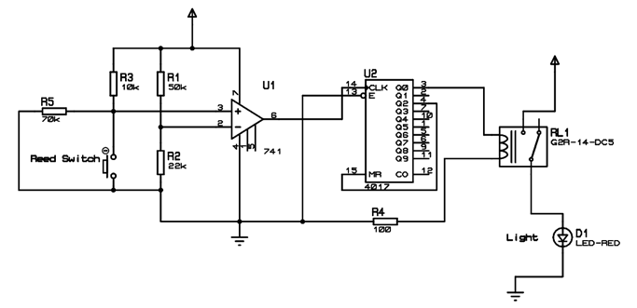

Exsiting Method:

* various technologies and methods were being used to create smart public restrooms. These methods incorporate advanced technology to improve user experience, hygiene, resource management, and accessibility.These existing methods and technologies collectively create a smarter, more efficient, and user-friendly public restroom experience. They address issues related to hygiene, resource management, accessibility, safety, and user satisfaction, making public restrooms a more pleasant and sustainable urban amenity.

Working Principle:

* The working principle of a smart public restroom revolves around the integration of advanced technology to improve various aspects of the restroom experience, including hygiene, resource management, accessibility, security, and user satisfaction.

Proposed Method:

* Creating a proposed method for a smart public restroom involves outlining the steps and strategies for designing and implementing an advanced, user-friendly, and efficient public restroom facility.

Code Implementation:

The code implementation involves developing the software for IoT devices and the platform:

* For IoT devices the code includes programming occupancy and water sensors to transmit data to the platform, as well as controlling lighting systems.
* The platform's code is responsible for data collection, analysis, and user interface. It uses Python for data processing and provides a web-based interface for users and maintenance staff.

Source Code:

import time

class Restroom:

def __init__(self):

self.occupancy = False

self.lighting = False

self.toilet_paper_level = 100 # Initial toilet paper level in percentage

self.water_usage = 0 # Total water usage in liters

self.temperature = 25 # Initial temperature in Celsius

self.humidity = 40 # Initial humidity in percentage

def enter(self):

if not self.occupancy:

print("Welcome to the restroom. The door is now unlocked.")

self.occupancy = True

else:

print("The restroom is currently occupied. Please wait or try again later.")

def exit(self):

if self.occupancy:

print("Thank you for using the restroom. The door is now locked.")

self.occupancy = False

else:

print("The restroom is already vacant.")

def toggle_lighting(self):

self.lighting = not self.lighting

if self.lighting:

print("Restroom lighting is now ON.")

else:

print("Restroom lighting is now OFF.")

def dispense_toilet_paper(self):

if self.toilet_paper_level > 0:

print("Toilet paper dispensed.")

self.toilet_paper_level -= 10 # Simulate dispensing 10% of the toilet paper

else:

print("Out of toilet paper. Please notify the staff.")

def flush_toilet(self):

print("Toilet flushed.")

self.water_usage += 3 # Simulate 3 liters of water usage

def adjust_temperature_humidity(self, temp, humidity):

self.temperature = temp

self.humidity = humidity

def status_report(self):

print(f"Restroom Status:")

print(f"Occupancy: {'Occupied' if self.occupancy else 'Vacant'}")

print(f"Lighting: {'ON' if self.lighting else 'OFF'}")

print(f"Toilet Paper Level: {self.toilet_paper_level}%")

print(f"Water Usage: {self.water_usage} liters")

print(f"Temperature: {self.temperature}°C")

print(f"Humidity: {self.humidity}%")

def main():

restroom = Restroom()

while True:

print("\nOptions:")

print("1. Enter the restroom")

print("2. Exit the restroom")

print("3. Toggle lighting")

print("4. Dispense toilet paper")

print("5. Flush toilet")

print("6. Adjust temperature and humidity")

print("7. Check restroom status")

print("8. Quit")

choice = input("Enter your choice (1-8): ")

if choice == '1':

restroom.enter()

elif choice == '2':

restroom.exit()

elif choice == '3':

restroom.toggle_lighting()

elif choice == '4':

restroom.dispense_toilet_paper()

elif choice == '5':

restroom.flush_toilet()

elif choice == '6':

temp = float(input("Enter new temperature (°C): "))

humidity = float(input("Enter new humidity (%): "))

restroom.adjust_temperature_humidity(temp, humidity)

elif choice == '7':

restroom.status_report()

elif choice == '8':

print("Exiting the smart restroom system.")

break

else:

print("Invalid choice. Please enter a valid option (1-8).")

if __name__ == "__mai

main()

Objectives:

The primary objectives of the Smart Public Restroom project are:

* Enhanced Hygiene and Cleanliness: To create a public restroom that maintains high standards of hygiene and cleanliness.
* Resource Efficiency: To optimize the use of resources such as water and electricity.
* Improved User Experience: To enhance the overall user experience by offering convenient and smart features.
* Data-Driven Maintenance: To monitor the restroom's conditions and perform maintenance based on data, ensuring a consistent user experience.

IoT Device Setup:

The restroom is equipped with a variety of IoT devices, including:

Occupancy Sensors:

* These sensors detect when a person enters or leaves the restroom, allowing for better resource management.

Water Sensors:

* These sensors monitor water usage, ensuring that faucets and toilets are not left running.

Air Quality Sensors:

* These sensors measure air quality, ensuring proper ventilation and air purification.

Paper Supply Sensors:

* These sensors monitor the availability of paper towels and toilet paper, alerting maintenance staff when restocking is required.

Lighting Controls:

* Smart lighting systems adjust lighting levels based on occupancy and natural light, saving energy.

Security Cameras:

* For security and safety purposes, cameras are installed.

Platform Development:

The data from these IoT devices is collected and analyzed by a centralized platform. The platform has the following key features:

Data Collection and Analysis:

* The platform collects data from IoT devices in real-time and analyzes it to provide insights into restroom usage.

Alerts and Notifications:

* The platform sends alerts to maintenance staff when supplies are low or when issues are detected.

User Interface:

* An intuitive user interface is accessible to users, allowing them to check occupancy status and request maintenance if necessary.

Energy Management:

* The platform optimizes energy use by controlling lighting and ventilation systems based on occupancy and natural light.

Advantages:

* Resource Efficiency.
* Real-time Monitoring.
* Accessibility.
* User-Friendly Experience.
* Amenities.
* Improved Safety.
* Cost Savings.
* Environmental Sustainability.
* Data-Driven Decision Making.

Disadvantages:

* High Initial Costs.
* Maintenance and Repairs.
* Privacy Concerns.
* Technology Dependence.
* User Learning Curve.
* Accessibility for All.
* Power Outages.

Conclusion:

* In conclusion, the concept of a smart public restroom represents a significant advancement in urban infrastructure, enhancing the quality of life for residents and visitors while promoting sustainability and resource efficiency. By leveraging cutting-edge technology and innovative design principles, smart public restrooms offer a range of benefits that address long-standing challenges associated with conventional public restrooms.